

LoRaWan public/private gateway

(Topic Analysis)

Word count: 3010

Submitted for : Msc Computer Science (Security and distributed)

Completed by: Ieaun Roberts

Supervisor : Dr John Dixon

Date: 5-28-2020

Contents

1. Introduction 2

1.1. Problem 2

1.2. Goal 2

1.3. Ethics, fair use and legal issues 3

2. Background 5

2.1. LoRa and LoRaWAN 5

2.2. The Things Network 6

2.3. Hardware systems 6

2.4. Technical background 9

3. Specification and analysis 12

3.1. Specification 12

3.2. Hardware analysis 14

3.3. LoRa use cases and applications 1

4. Project management 0

4.1. Timeline 0

4.2. Task list 0

4.3. Overview of tasks 1

4.4. Project risks 2

4.5. Time Plan 0

5. Appendix 0

Appendix 1.1: Original topic description 0

Appendix 1.2: 0

6. References 0

# Introduction

Herein lies the initial research and analysis for the topic titled “LoRaWan public/ private gateway”. This topic revolves around the use of the LoRa and LoRaWAN protocols to facilitate and manage the communication between end nodes, gateways and servers. The primary goal is the development of a LoRaWAN gateway capable of forwarding packets to either designated private servers or the Things Network.

Within this initial report we touch on subjects relating to wireless communications while comparing and contrasting the hardware used to enable these technologies and cover aspects relating to project management for the topic.

## Problem

LoRaWAN is only functional with a gateway to forward packets within the vicinity. End nodes broadcast their data and gateways in range receive these packets and typically forward them to “The Things Network” where other applications can obtain the data.

The more gateways available, spread out in different locations, the more usable LoRaWAN becomes.

Private organizations are often uncomfortable with sharing their data with 3rd parties (e.g. the Things Network). This leads to the use of private infrastructure that only routes data to private servers, rendering the infrastructure unusable for outside devices.

What is needed is a gateway capable of forwarding packets to alternating sources:

* 1. Private data sent to requested servers.
  2. All other data sent to the Things Network.

## Goal

Build a multi-channel gateway, create software to meet the outlined functionality, develop a web application to enable users to register end node – server relationships to ensure their data is routed to the correct location and provide an in-depth examination of the LoRa and LoRaWAN protocols.

**End-nodes**

**Gateways**

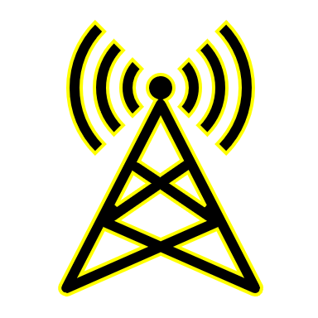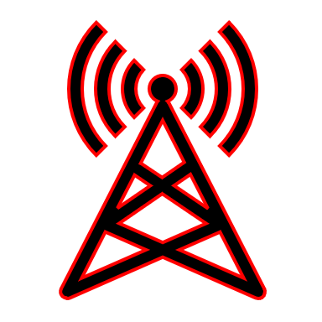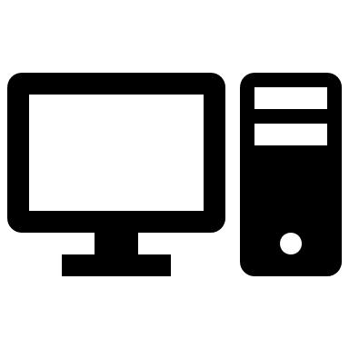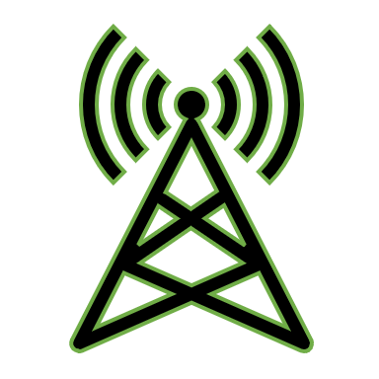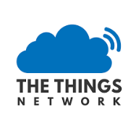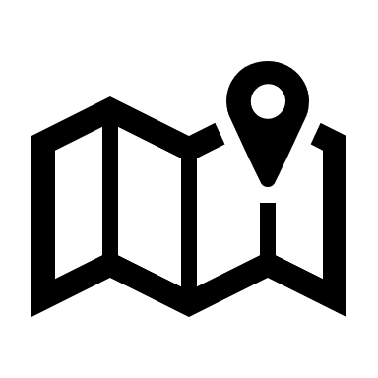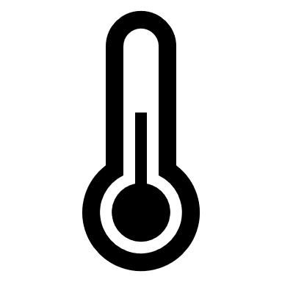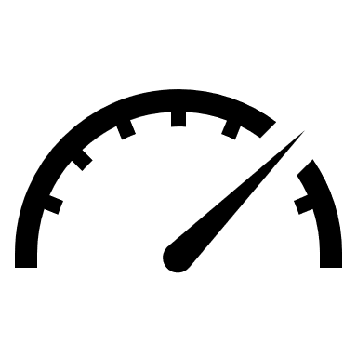

**Figure 1, Proposed public / private LoRaWAN Network topology**

Private

Hybrid

Private

Uplink

Downlink

Public

Application server

Network Server

Application server

Speedometer

Temperature

Location

Humidity

Public

## Ethics, fair use and legal issues

LoRa makes use of unlicensed ISM bands (Industrial, Scientific and Medical) to communicate data. Use of these ISM bands is heavily restricted and anyone intending to create a LoRa based system should familiarize themselves with the relevant documentation regarding which frequency to use, duty cycle limitations, ERP/EIRP and max antenna gains in their country. Systems, installations and infrastructure not upholding local regulations may be punishable by your residing government.

An in-depth breakdown of specific LoRa frequencies per country can be found by visiting <https://www.thethingsnetwork.org/docs/lorawan/frequencies-by-country.html>

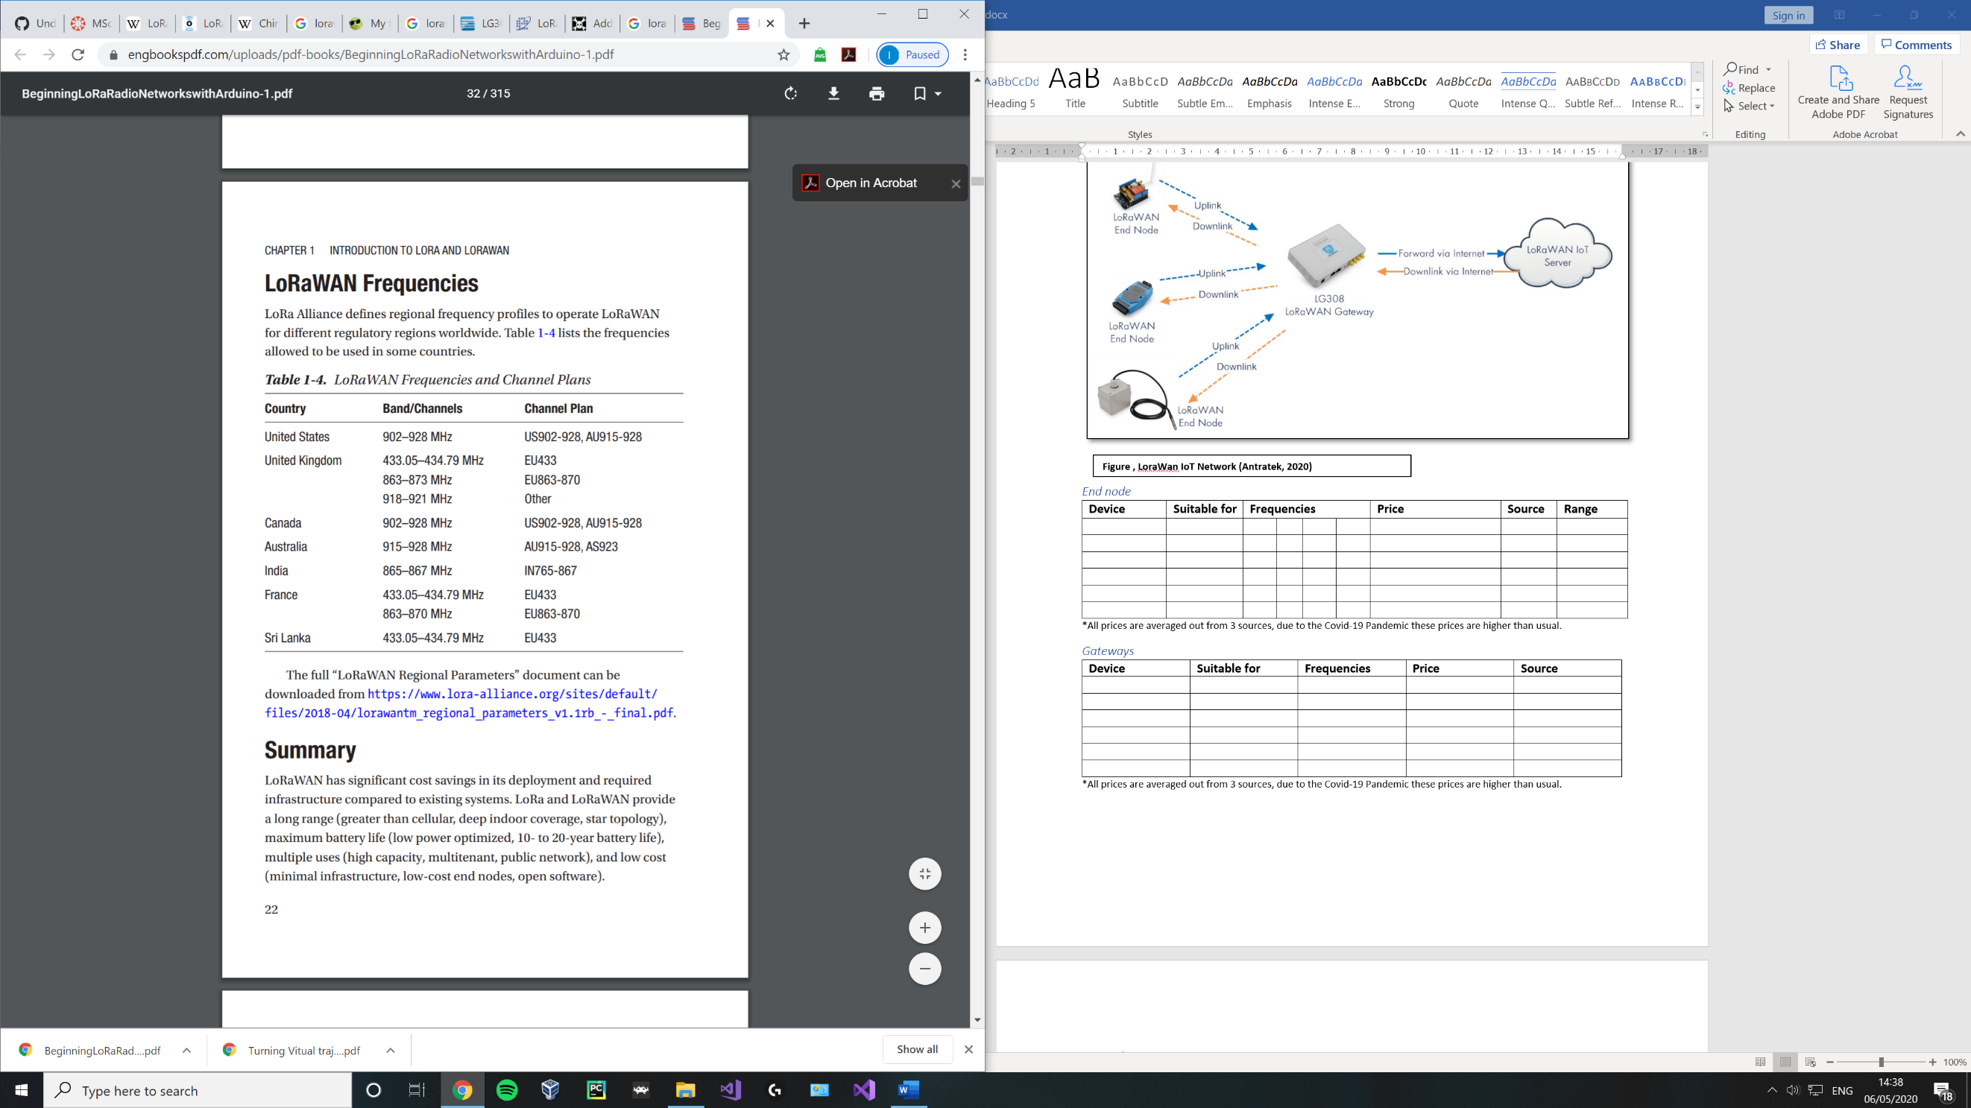

**Figure 2, LoRaWAN IoT Network** (Seneviratne, 2019)

##### Duty Cycle

The duty cycle can be described as a proportion of a period, during which a system’s transmission is allowed to be active and is commonly expressed as a percentage or ratio.

The duty cycle for the EU 863 – 870Mhz ISM band is 1%, other bands, sub bands and locations may have a 0.1% restriction. (lora-alliance, 2015)

A 1% duty cycle indicates a system is not permitted to transmit data on the current band until it has waited for at least 99% of the time it took to send the previous packet.

**Time on air** – the length of the period expressed in time for a sender’s packet to reach a receiver.

**Waiting…**

Signal

Signal

e.g. Time on Air – 620ms

Duty cycle – 1%

99x620 = 61380 = 61.38 seconds

**Waiting…**

Signal

Signal

e.g. Time on Air – 620ms

Duty cycle – 0.1%

999x620 = 619 380 = 619.38 seconds

**Figure 3 adapted from** (Mobilefish, 2018)**, Duty cycle calculation**

Without duty cycles in place limiting use, bands may be rendered unusable akin to a DoS attack and gateway functionality may be affected.

Use of multiple bands / channels to work around this limitation is common practice.

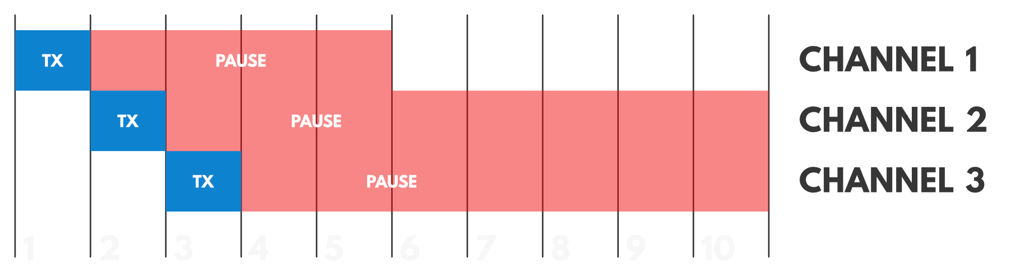

**Figure 4, Multiple sub-band transmission** (thethingsnetwork, n.d.)

##### The Things Network policies

The organizations fair use policy limits end-node transmission in a 24-hour period to a maximum of :

* 30 seconds of uplink airtime.
* 10 downlink messages (including ACKs).

(thethingsnetwork, n.d.)

# Background

## LoRa and LoRaWAN

#### What is LoRa ?

LoRa (Long Range) is a patented physical layer wireless communication technology developed by Semtech. It is a spread spectrum modulation technique derived from **chirp spread spectrum**. LoRa is a data transmission alternative that is often praised for its low power consumption and long-range abilities and is suited for scenarios where infrequent small data packets need to be sent. It is especially useful in IoT (Internet of things) networks. (semtech, n.d.)

LoRa uses licence free, amateur ISM bands such as 868Mhz in Europe and is able to transmit to various far off distances (greater than current cellular networks) due to its high **link budget**.

|  |  |
| --- | --- |
| **Environment** | **Range (km)** |
| Urban | 2-5 |
| Rural | 5-15 |
| Direct line of sight | >15 |

Figure 5, LoRa range

Record: 436 miles / 702Km, Weather balloon to ground connection (TTN, 2017)

Distance heavily dependent on environment and materials within.

LoRa includes the use of several layers of encryption that make use of a:

1. Unique network key.
2. Unique Application key.
3. Device specific key.

(lora-alliance, n.d.)

#### What is LoRaWAN ?

LoRaWAN is an LPWAN protocol (Low Power Wide Area Network) based on LoRa technology. As with other LPWAN protocols such as Sigfox, it is able to transmit data over great distances at low data rates and minimal power consumption. LoRaWAN defines the upper networking layers and LoRa defines the lower physical layer.

“LoRaWAN was designed to wireless connect battery operated things to the internet.” (semtech, n.d.)

LoRaWAN is used to manage and route communications between asynchronous end nodes and gateway devices. Its emphasis is on management of communications and revolves around the architecture of the network, managing communication frequencies and data rates.

LoRaWAN’s network architecture takes the shape of a star-of-stars topology, with gateways forwarding payloads between end nodes and servers with the conversion of radio frequency (RF) packets to Internet protocol (IP) packets and vice versa throughout. (lora-alliance, n.d.)

## The Things Network

The things network provides a decentralized data network based on LoRaWAN to support in the development of IoT applications. In practice, end nodes transmit data to gateways who in turn forward the data to the Things Network servers where application servers can receive the end node data. (thethingsnetwork, n.d.)

## Hardware systems

##### End Nodes

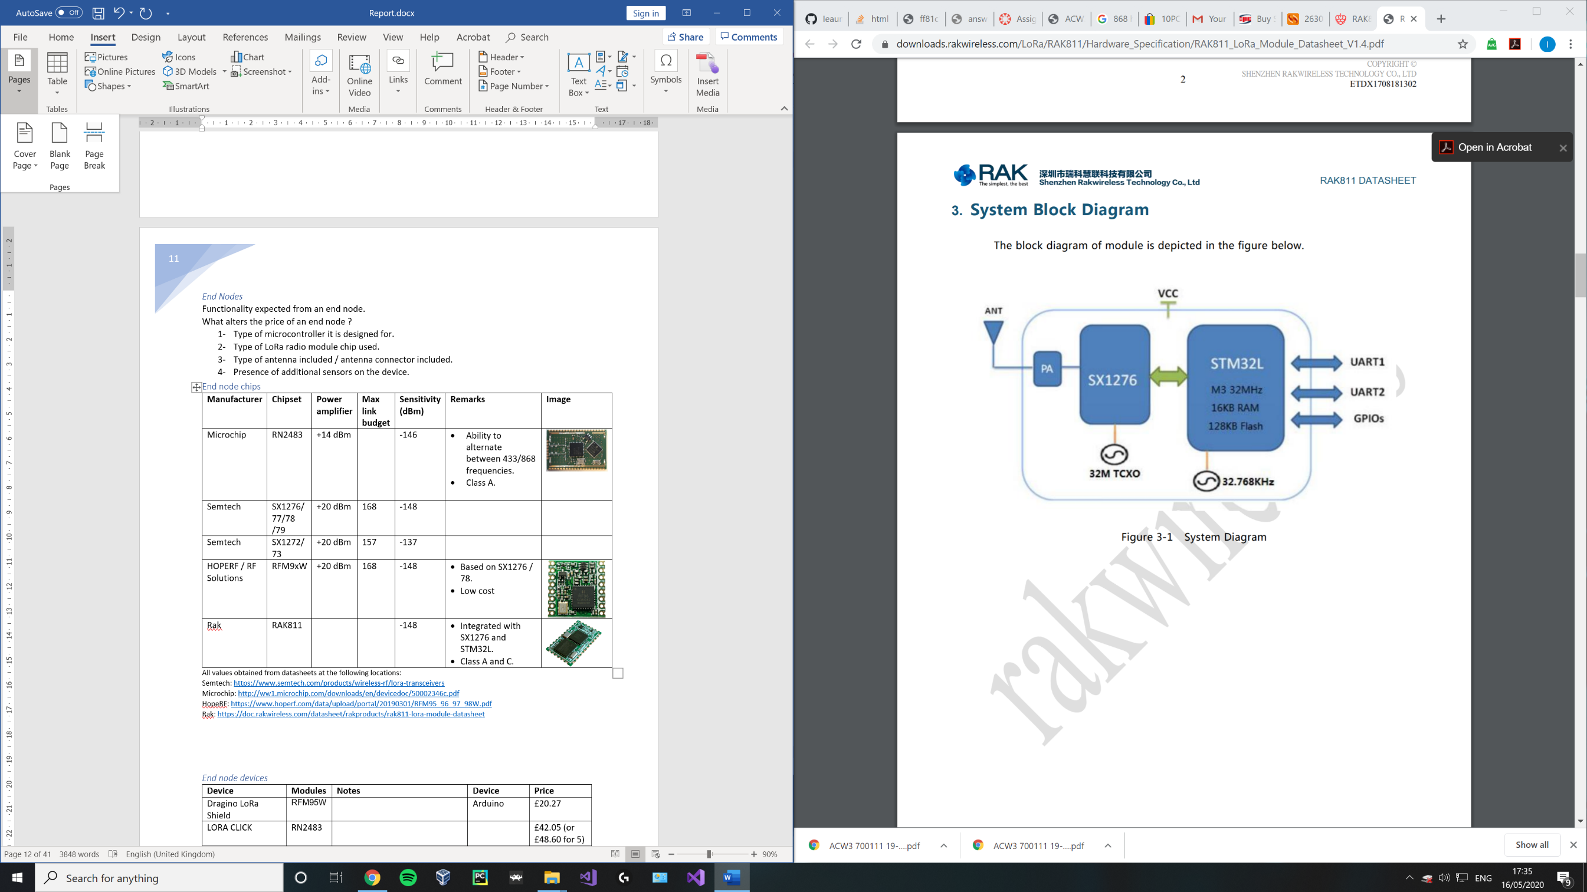End nodes are typically a battery powered device, making use of some form of sensor, transmitting its values to a gateway.

Among others, some performance constraints of an end node are determined by:

1. Type of microcontroller / processor.
2. Type of LoRa radio module chip (pictured right).
3. Type of antenna.
4. Presence of additional sensors on the device.

**Figure 6, RAK811 system diagram** (RAK, n.d.)

#### Gateways

LoRaWAN gateways are devices used to receive packets from numerous end nodes. Typically, packets are received simultaneously on multiple channels via LoRa and their payloads are forwarded to standard IP servers over the internet. Multiple gateways can receive a single end nodes broadcast if within the vicinity. (lora-developers, n.d.) (lora-alliance, n.d.)

Among others, some performance constraints of an gateways are determined by:

1. Type of concentrator board used to receive LoRaWAN packets.
2. Type of antenna.
3. Type of LoRa radio module chip used.

Every gateway has a:

* Processor to demodulate a signal.
  + In the case of the SX1301, the chip can scan and detect packet preambles in 8 channels and simultaneously demodulate packets on all 8 channels. It is unable to scan and demodulate at the same time. (semtech, n.d.)
* One / two TX/RX radios (SX1255)

##### Device classes

The LoRaWAN specification defines 3 different classes of end node / end point devices. These classes address the needs of different devices in terms of power consumption and latency. (lora-alliance, 2015)

The following terms are used below in the perspective of an end node:

**Uplink** **(Tx)** – Data transmission from end node to gateway.

**Downlink (Rx)** – End node listening to receive data from gateway.

###### Class A (All)

This default class is supported by all devices. For class A devices, each uplink transmission is followed by 2 short windows to receive a downlink response from a gateway. During this period after sending an uplink, the device can enter a low power state while it waits for either of the window times to begin. Once a window period starts, it should listen for a response from the gateway.

Gateways are expected to respond in either the first or second window but not both. If a gateway fails to respond in these windows, the next available receive window for that device will be after the next Tx uplink.

* Lowest power

Downlink window 2 (Rx)

Uplink (Tx)

Downlink window 1 (Rx)

**Time**

**T1**

**T2**

**Figure 7 adapted from** (MobileFish, 2018)**, Class A device**

###### Class B (Beacon)

Furthering class A’s specification, this class provides additional periodical receive windows in the form of “ping slots” within a scheduled allocation of time via beacons. These beacons are determined by the gateway and mark the beginning and end of the period during which the node is listening for packets periodically from the gateway. This leads to a lower deterministic latency when compared to class A devices, this comes at the cost of additional power. (lora-alliance, n.d.)

* Low power
* Low latency

**Class A**

Rx

Rx

Rx

Rx

Rx

Tx

**Time**

**Beacon**

**Beacon**

**Ping period**

**Beacon period**

**Figure 8 adapted from** (MobileFish, 2018)**, Class B device**

###### Class C (Continuous)

Furthering class A’s specification, after the two windows have elapsed this class proceeds to continuously listen for responses until this device needs to send another uplink in a half-duplex manner. Gateways communicating with these types of devices may assume that the device is always listening reducing latency.

This class of devices uses far more power and is often mains powered as opposed to battery powered. For battery powered devices, temporary mode switching from class C to class A is possible as defined in the LoRa specification. (lora-alliance, n.d.)

* Lowest latency

**Class A**

Rx (until next uplink)

Rx

Rx

Tx

**Time**

**Figure 9 adapted from** (MobileFish, 2018)**, Class C device**

The above information on classes was adapted from the following sources (lora-alliance, n.d.) (thethingsnetwork, n.d.) (lora-developers, n.d.) (MobileFish, 2018)

## Technical background

#### Propagation

Propagation covers the way radio waves travel from a transmitter to a receiver and how signal strength is affected if traveling through a medium.

There are 4 main types of propagation:

1. Line of sight propagation – radio wave transmits directly from sender to receiver without any obstacle in its path.
2. Propagation through obstacles – radio waves lose strength proportional to the conductivity of the material when penetrating through obstacles.
3. Propagation through reflection – In terms of obstacles within the **Fresnel zone,** radio waves may be reflected off of objects and received later than the original line of sight signal reducing the power of the signal and interfering with other direct signals. Dependant on when a reflected signal is received it can either enhance or cancel out a direct line of sight signal.
4. Propagation through diffraction – when radio waves have to travel around sharp edges / large objects to reach a receiver.

Free space loss – the single largest loss in radio communication systems and is due to large distances between senders and receivers. (Mobilefish, 2018)

Receiver

Sender

Receiver

Sender

**Figure 11, propagation through reflection**

**Figure 10, Line of sight propagation**

Receiver

Sender

Sender

Receiver

**Figure 13, propagation through diffraction**

**Figure 12, propagation through obstacles**

#### Fresnel Zone

The Fresnel zone is an elliptical area centred around the direct line of sight path between a point-to- point sender and a receiver in wireless communications. Any obstacles within this zone impacts signal strength due to either reflection, diffraction or penetration.

**Distance**

**Maximum radius**

**Line of sight**

Sender

Receiver

**Height**

**Height**

**60% clear**

**Figure 14 adapted from** (mobilefish, 2018)**, Fresnel zone**

Altering the distance between the sender and receiver similarly affects the size of the maximum radius of the zone. In the figure above, increasing the distance eventually leads to the ground entering the Fresnel zone causing signals to be reflected to the receiver, interfering with line of sight signals. (Mobilefish, 2018)

General tips to improve Fresnel zone coverage and radio signal performance include:

* Placing receivers at higher locations to avoid interference. At large distances, the earths curvature becomes a factor.
* Ensuring the zone is at least 60% clear of blockage.
* Use of optimized antennas based on regional and environmental factors.
* Ensure antenna polarisation for sender and receiver is the same. (e.g. both vertical)

#### Link budget

**Modulation** – the process of impressing information onto a radio frequency carrier wave. (britannica, n.d.)

**Demodulation** – recovering information from a modulated radio frequency carrier wave.

The link budget is a metric used to quantify the coverage and performance in terms of signal strength of a wireless communication system. Calculation of the link budget requires a summation of all gains and losses experienced within the sender device after modulation, in transmission and when being received and demodulated.

Additional concepts around link budget include:

Received /Rx power: transmitted power + gains – losses measured in dBm

Received /Rx sensitivity: lowest power level at which the receiver is able to demodulate the signal.

Link margin: difference between received power and sensitivity.

(mobilefish, 2018)

LoRa receivers offer a low sensitivity (typically -148) which means they are able to demodulate signals at lower power levels due to the use of chirp spread spectrum.

Maximum link budgets can be calculated by subtracting the lowest Rx sensitivity from the maximum Rx power. This value can be used to directly compare radio performance.

|  |  |  |
| --- | --- | --- |
| **Chip name** | SX1276 | SX1272 |
| **Rx sensitivity** | -148 dBm | -137 dBm |
| **Rx power** | 20 dBm | 20 dBm |
| **Maximum link budget** | 168 dBm | 157 dBm |

**Figure 15, SX1276 vs SX1272**

Values obtained from datasheets: <https://www.semtech.com/products/wireless-rf/lora-transceivers>

Additional topics to research include:

#### Chirp spread spectrum (CSS)

#### Frequency shift keying (FSK)

# Specification and analysis

## Specification

The aim of this project is to produce a LoRaWAN gateway capable of handling both private and public end node data to provide a hybrid alternative to closed private LoRaWAN networks which are preferred by industry users due to privacy concerns.

In the hybrid implementation data would be considered private if the end node is registered to the system, otherwise it is assumed public. Private data is forwarded to a specified server, public data is routed to the Things Network.

The work includes extensive research on wireless communication methodologies and LoRaWAN hardware, building a multi-channel gateway, writing software to meet the aforementioned functionality, developing a web application to register end node – server relationships and providing an in-depth examination of the LoRa and LoRaWAN protocols.

#### **Objective 1: Research into wireless communications and LoRaWAN**

The aim of this objective is to obtain a strong foundation in wireless communication methodologies, within which an emphasised amount of care should be given to modulation techniques, radio wave propagation, LPWAN, LoRa and LoRaWAN. Without a solid understanding of wireless communications concepts, justification and contrasting of hardware components will not be possible.

#### **Objective 2: Research into hardware used by LoRaWAN devices**

The aim of this objective is to examine datasheets and online resources with the goal of comparing and contrasting different hardware components that will be used to build the gateway. With some individual components costing over £100, it is important to thoroughly understand the pros and cons of each components.

#### **Objective 3: Create a peer-to-peer LoRa network**

The aim of this objective is to experiment with data transfer using LoRa at a basic level. In this objective, hardware must be obtained and software must be written (C/ Python/ Arduino) to transfer simple data from one end node and to receive that data on another device.

#### **Objective 4: Further research into LoRaWAN gateway hardware**

The aim of this objective is to finalize the research on LoRaWAN gateway hardware components and to make an informed decision based on prior and current research as well as the peer–to–peer experiment on which components will be ordered.

#### **Objective 5: Creation of a public LoRaWAN gateway**

The aim of this objective is to assemble the obtained hardware, set it up (Linux OS) and write the software necessary to perform typical public gateway functionality (C/ Python/ Arduino) and register the gateway on the things network.

#### **Objective 6: Creation of registration system**

The aim of this objective is the creation of a web application that can be used to register end node – server relationships (Asp.net, SQL server)

#### **Objective 7: Hybrid LoRaWAN gateway**

The aim of this objective is to integrate the registration system with the public gateway to forward any data from registered end points to their required server.

#### **Objective 8: Security concerns**

The aim of this objective is to examine the created system, identify security concerns and rectify them to align with the secure nature of LoRa. This objective will be considered throughout development.

#### **Objective 9: Exploration and implementation of LoRaWAN use cases**

The aim of this objective is to implement a subset of the outline use cases and identify any short comings and possible improvements that could be made to the gateway.

#### **Objective 10: Additional objectives**

The aim of this objective is to use the remaining time to improve the gateway and use the expertise gained throughout the system development and research to identify possible additional objectives that require a more technical and in-depth knowledge of the LoRaWAN protocol.

## Hardware analysis

Semtech has licenced the LoRa IP to a handful of chip manufacturers such as HopeRF, Rak and Microchip. (semtech, n.d.)

Below are initial summarized findings for the following devices, components and modules:

* End node chips (SX1276)
* End node devices (Dragino LoRa Shield)
* Gateway chips (SX1301)
* Gateway devices (Kerlink WirNet Station)
* Concentrator gateway boards (iC880A-SPI)
* Single board PC’s (Raspberry Pi 3 B+)

To Do:

* Antennas

##### End node chips

|  |  |  |  |  |  |  |
| --- | --- | --- | --- | --- | --- | --- |
| **Manufacturer** | **Chipset** | **Max**  **Power amplifier** | **Max link budget** | **Sensitivity (dBm)** | **Remarks** | **Image** |
| Microchip | RN2483 | +14 dBm |  | -146 | * Ability to alternate between 433/868 frequencies. |  |
| Semtech | SX1276/ 77/78 /79 | +20 dBm | 168 | -148 | * Extensive datasheet. |  |
| Semtech | SX1272/ 73 | +20 dBm | 157 | -137 | * Extensive datasheet. |  |
| HOPERF / RF Solutions | RFM9xW | +20 dBm | 168 | -148 | * Based on SX1276 / 78. * Low cost. * Extensive datasheet. |  |
| Rak | RAK811 | +20 dBm |  | -148 | * Integrated with SX1276 and STM32L. * Class A and C. |  |

**Figure 16, End node chips**

All values obtained from datasheets at the following locations:

Semtech: <https://www.semtech.com/products/wireless-rf/lora-transceivers>

Microchip: <http://ww1.microchip.com/downloads/en/devicedoc/50002346c.pdf>

HopeRF: <https://www.hoperf.com/data/upload/portal/20190301/RFM95_96_97_98W.pdf>

Rak: <https://doc.rakwireless.com/datasheet/rakproducts/rak811-lora-module-datasheet>

#### End node devices

|  |  |  |  |  |
| --- | --- | --- | --- | --- |
| **Device** | **Modules** | **Notes** | **Device** | **Price** |
| Dragino LoRa Shield | RFM95W/ SX1276 | Lower current consumption than competing devices. Temp sensor and low battery indicator. | Arduino | £20.27 |
| LORA CLICK | RN2483 | - | - | £42.05 (or £48.60 for 5) |
| I-NUCLEO-LRWAN1 | SX1272 | Accelerometer, humidity, magnetometer, pressure and temperature sensors. | Arduino | £23.64 |
| Dragino Pi shield 113990254 | RFM95W | Lora/GPS | Raspberry Pi | £26.68 |
| Dorji (DRF1276DM) | SX1276 | - | - | £9.10 |
| DM164138 | RN2483 | All in one device with built in sensors / LCD. | - | £56.14 |
| RAK811 LPWAN | RAK811 | Arduino shield / standalone device. | Arduino | £17.17 |
| RAK811 LoRa / Tracker Board | RAK811 | GPS, open source. | - | £40.99 |
| pHat PIS-1128 | RAK811 | - | Raspberry Pi | £29.99 |
| Adafruit LoRa breakout | RFM96W | Breakout board. | - | £15.12 |

**Figure 17, End node devices**

*Prices are illustrative only and were collected on +-13/05/2020, due to the Covid-19 Pandemic and effects on supply chains these prices may appear higher than usual.

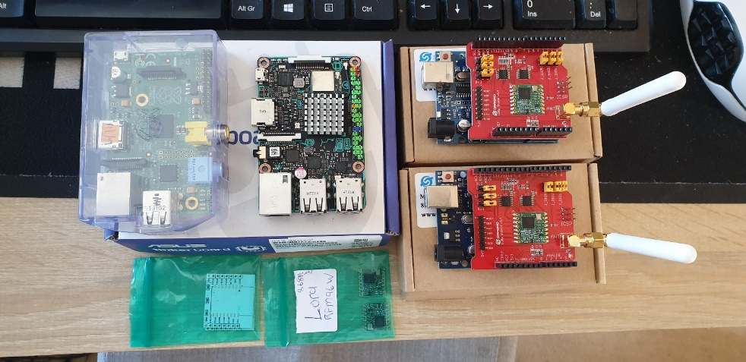

**Figure 18, 2 obtained Dragino LoRa Shields and 2** **RFM95W modules.**

##### Gateway chips

|  |  |  |  |  |  |
| --- | --- | --- | --- | --- | --- |
| **Manufacturer** | **Chipset** | **Sensitivity (dBm)** | **Remarks** | **Max end nodes** | **Channels** |
| Semtech | SX1301 | -142.5 (SX1256)  -139.5 (SX1255) | Emulates 49x LoRa demodulators. | 10000 | 8 |
| Semtech | SX1308 | -139 (SX1255, SX1257) | 70db CW interferer rejection. | 10000 | 8 |
| Semtech | SX1257 | - | RF-to-digital front-end transceiver | - | - |

**Figure 19, Gateway chips**

All values obtained from datasheets at the following locations:

Semtech: <https://www.semtech.com/lora/lora-products>

##### Gateways devices

|  |  |  |  |  |
| --- | --- | --- | --- | --- |
| **Device** | **Chipset** | **Notes** | **Type** | **Price** |
| Mikrotik, LoRa8 | R11e- Lora8 | Listen Before Talk (LBT) and spectral scan features | Outdoor | £156.59 |
| The Things industries, TTIG-868 | SX1308 | USB-c, 900mA, LBT, Lora GW board, Basic station protocol | Indoor | £78.00 |
| TTN-GW-868 | - | No datasheet found for this device | - | £262.10 |
| Dragino LG01N/ OlG01N | SX1276/78  (x2 End node chips) | Single frequency, up to 300 nodes | Outdoor | £57.95 |
| Dragino LG02 | SX1276/78  (x2 End node chips) | Full duplex, 2 channels, optional 3G/4G module. | Outdoor | £74.36 |
| Cisco LoRaWan Gateway | SX1301 (x2) | GPS, rich software features, 16 channels | Outdoor | £2055.21 |
| Kerlink IFemtoCell | SX1301  SX1257 (x 2) | 49 demodulators over 9 channels | Indoor | £266.78 |
| Kerlink WirNet Station | - | 49 demodulators on 9 channels, bidirectional.  Most popular gateway in the UK. | Outdoor | £1010.79 |
| Laird RG186 Sentruis | SX1301  SX1257 | Popular gateway in the UK. | Outdoor | £220.80 |

**Figure 20, Gateway devices**

*Prices are illustrative only, due to the Covid-19 pandemic and effects on supply chains these prices may appear higher than usual.

All values obtained from datasheets and resources at the following locations:

Laird: <https://connectivity-staging.s3.us-east-2.amazonaws.com/2020-03/CS-PB-RG1xx-GATEWAY_v1_5.pdf>

Dragino: <https://www.dragino.com/products/lora-lorawan-gateway/item/135-lg02.html>

Kerlink:<https://www.thethingsnetwork.org/forum/uploads/default/original/1X/1be8efc08586c0bb5676689df122a3628fe3e0e1.pdf>

Mikrotik: <https://i.mt.lv/cdn/rb_files/1575622904wap%20lora8.pdf>

Cisco: <https://www.cisco.com/c/en/us/products/collateral/se/internet-of-things/datasheet-c78-737307.html>

##### Single board PC’s

|  |  |  |  |  |
| --- | --- | --- | --- | --- |
| **Device** | **CPU** | **Ram** | **Remarks** | **Price** |
| Asus Tinker Board | 1.8GHz Quad-core ARM-based Rockchip RK3288 | 2GB | Built in WIFI and Bluetooth. | £62.48 |
| Raspberry Pi 3 B+ | 1.4GHz 64-bit quad-core processor | 1GB LPDDR2 SDRAM | High compatibility and large community. | £27.18 |
| BeagleBone Black | 1GHz AM3358  ARM Cortex-A8 | 512MB DDR3 | - | £49.86 |

**Figure 21, Single board PC’s**

##### Concentrator gateway boards

|  |  |  |  |
| --- | --- | --- | --- |
| **Manufacturer** | **Device** | **Remarks** | **Price** |
| IMST | iC880A-SPI - LoRaWAN Concentrator | SX1301, SX1257 (x 2) | £106.91 |
| Mikrotik | R11e- Lora8 / R11e- Lora 9 | Based on SX1301 | £73.23 |

**Figure 22, Concentrator gateway boards**

Mikrotik: <https://i.mt.lv/cdn/rb_files/1575622897User%20Manual%20R11e-LoRa8.pdf>

IMST: <https://wireless-solutions.de/downloadfile/ic880a-spi-documents/>

##### Overview of gateways in Hull, UK

##### What gateways are others using ?

|  |  |  |
| --- | --- | --- |
| **No** | **Brand / Model** | **Altitude (m)** |
| 1 | - | 150 |
| 2 | Raspberry Pi based, IMST | - |
| 3 | The Things Gateway | 34 |
| 4 | Raspberry Pi based, RAK831 | 1 |
| 5 | Raspberry Pi based, IMST | - |
| 6 | Raspberry Pi based 3 - 868.5Mhz | 8 |
| 7 | The Things Indoor Gateway | 3 |
| 8 | Mikrotik, LoRa8 | 15 |
| 9 | Mikrotik, LoRa8 | 5 |
|  | | |
|  | LoRa8 / raspberry pi IMST | 36 |

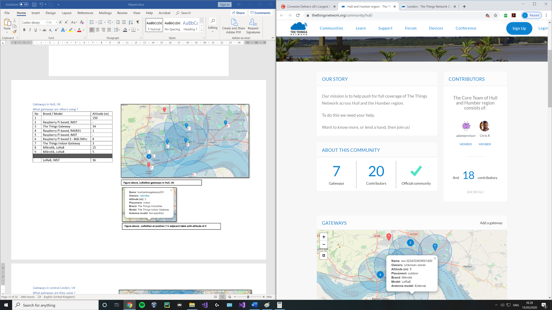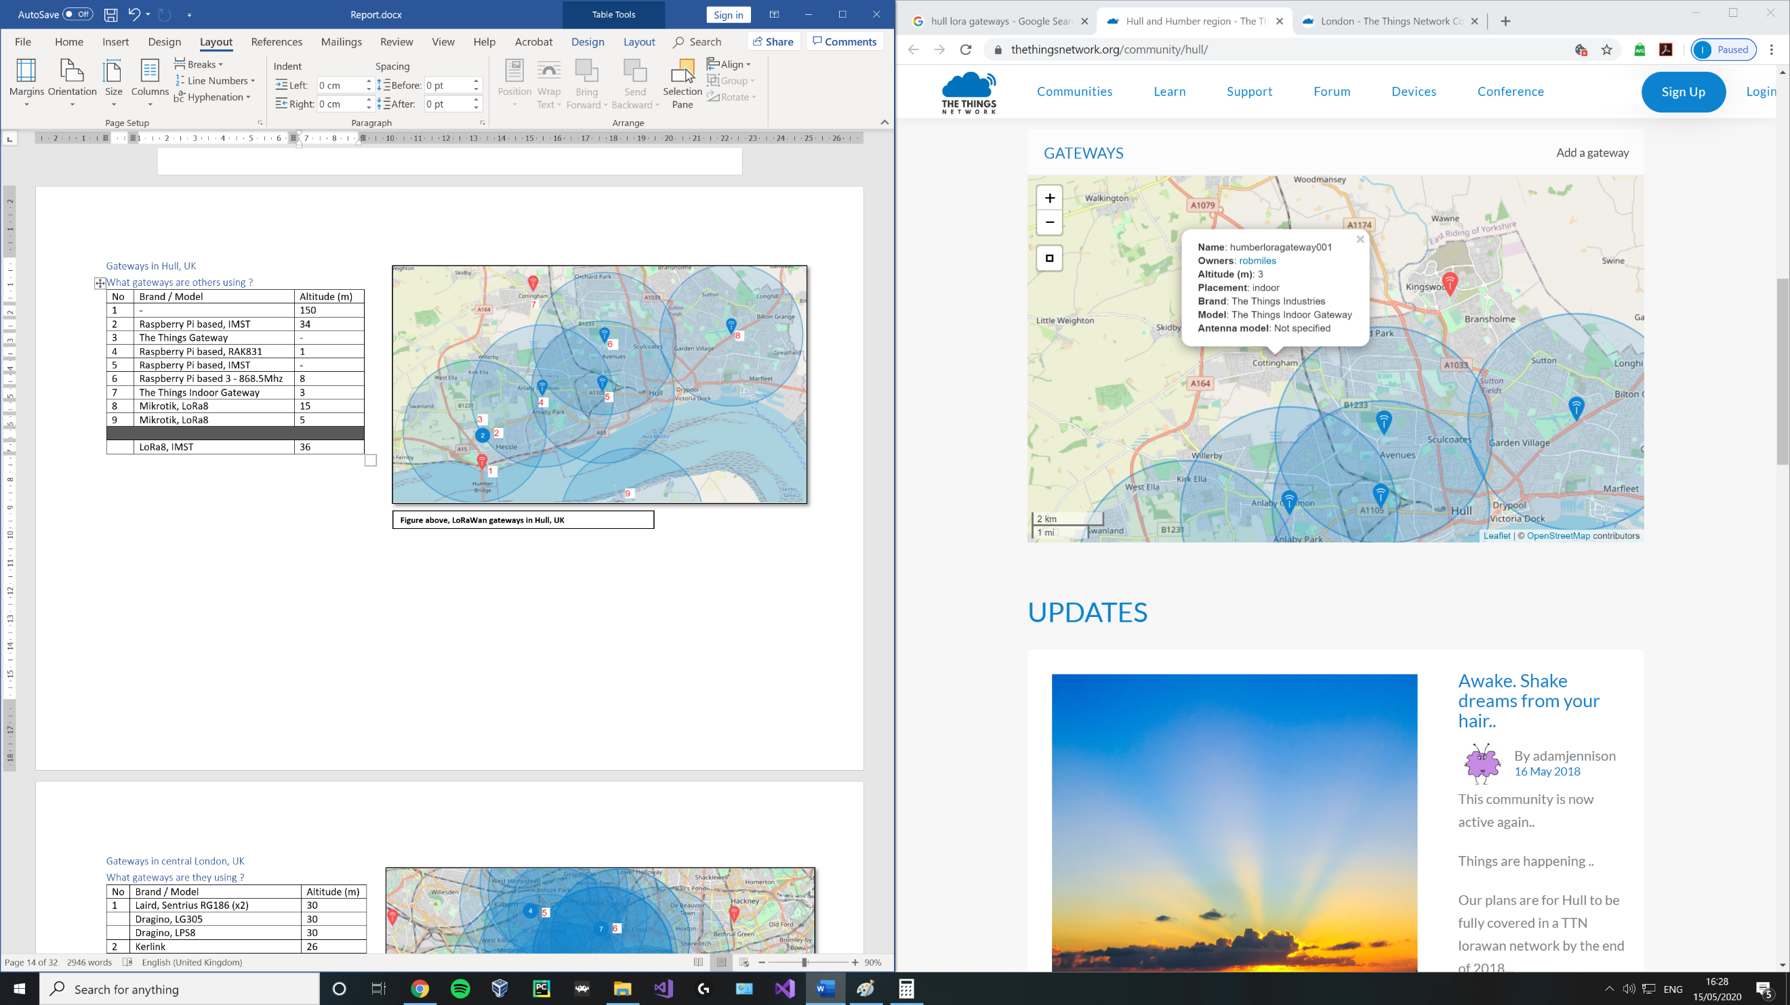

**Figure 24, LoRaWan gateway at position 7 in adjacent table with altitude of 3** (thethingsnetwork, n.d.)

**Figure 23, LoRaWan gateways in Hull, UK.** (thethingsnetwork, n.d.)

##### Summary of Overview

|  |  |  |  |  |
| --- | --- | --- | --- | --- |
| **Location** | **Number of gateways** | **Number of contributors** | **Most common device** | **Average altitude** |
| **Hull** | 7 | 20 | LoRa8 / raspberry pi IMST | 36 |
| **London** | 59 | 61 | Kerlink | 43 |
| **Manchester** | 11 | 46 | Kerlink, Station | 46 |
| **Liverpool** | 32 | 22 | IOTLTD v. 10 | 58 |
| **Birmingham** | 2 | 38 | The Things Indoor Gateway | 20 |
| **Leeds and Bradford** | 20 | 40 | Kerlink, Station / MultiTech, Conduit | 92 |

**Figure 25, Summary of Overview**

* See [Appendix 1.2] for overview of gateways used in London, Manchester, Birmingham, Liverpool and Leeds / Bradford.

|  |  |  |
| --- | --- | --- |
| **Rank** | **Device** | **Count** |
| 1 | The Things Indoor Gateway | 11 |
| 2 | Kerlink Station | 7 |
|  | Laird, Sentruis RG186 | 7 |
| 4 | The Things Gateway | 4 |
|  | Raspberry Pi based, IMST | 4 |

**Figure 26, Most popular devices from subset of locations in the UK**

*Only includes results where specific device name was provided.

*Number of gateways available and their altitude is constantly changing every day.

From the above overview of several cities in England, we can deduce that cities that are considered tech hubs are dominated by Kerlink gateways in the UK.

Kerlink was one of the initial players in the LoRaWan device market and its “Wirnet Station” holds the accolade of being the first LoRaWan gateway commercially available on the worldwide market launching in 2014. (kerlink, n.d.)

This predates both:

* The initial LoRaWan specification release by the LoRa Alliance in Jan 2015. (N. Sornin (Semtech), 2015)
* The Things Network launch in 2015. (wienkegiezeman, 2015)

Kerlink WirNet Stations are carrier grade private gateways intended for industry customers. Prices for a single base station range from £1010.79 - £1470.75 and include robust software and access to Kerlink’s “ITalks” LoRaWan server.

Further investigation is required into the functionality, hardware and technical operations in order to understand why WirNet and its later versions are still the preferred industrial gateway device for many experts.

## LoRa use cases and applications

#### Smart utilities

Automated meter reading.

Home and building automation.

Street lighting.

Smart parking.

Abnormal energy use detection.

Smart bus schedule signs.

#### Health and hygiene

Disaster precaution.

Waste management.

Food temperature control.

IoT connected hearing aids.

Alzheimer / Dementia patient tracking.

Smart wearables.

#### Safety

Off grid mobile phone messaging (Skrypt, 2019)

Wireless alarm and security systems.

Connected plugs for energy monitoring.

Water leak detection.

#### Efficiency

Industrial monitoring and control.

Location tracking.

Smart mining solutions.

Remote sensors in harsh environments.

#### Agriculture

Long range irrigation systems.

Environment monitoring.

Smart cattle ranching.

#### Other

IP over LoRaWan (Cola, 2018)

Majority of the use cases obtained on Semtech’s LoRa applications page. (semtech, n.d.)

# Project management

## Timeline

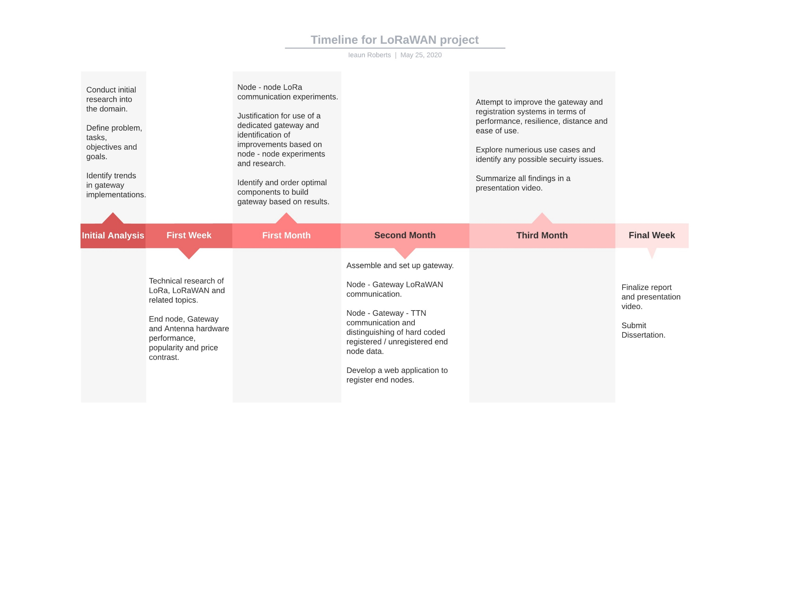

**Figure 27, Timeline for project made using LucidChart**

## Task list

|  |  |  |  |
| --- | --- | --- | --- |
| **#** | **Task name** | **Description** | **Duration (Days)** |
|  | **Research** | |  |
| 1.1 | Wireless communications | Propagation, Fresnel zone, link budget and margin, antennas and their configurations, packet forwarding techniques. | 3 |
| 1.2 | LoRa and LoRaWAN theory | Chirp speed spectrum, architectures, | 5 |
| 1.3 | (Optional) Encryption techniques | Investigate the practicality of encrypting easily obtained end node data and select a suitable technique to use. | 3 |
|  | **End node** | |  |
| 2.1 | Hardware | Research, compare and procure multiple optimal end node devices/end node hardware. | 3 |
| 2.2 | System design | Uml diagrams, prototype, requirement scoping | 1 |
| 2.3 | Software | Write / obtain libraries and code to make use of the purchased LoRa hardware on the devices. (Python or C/C++) | 2 |
| 2.4 | Node – Node communication  (peer- to- peer) | Create a single channel network of end nodes capable of communicating with one another and note the drawbacks. Justify the need for a dedicated gateway. | 2 |
|  | **Gateway** | |  |
| 3.1 | Hardware | Research, compare and procure a single board PC (e.g. Raspberry PI), a suitable antenna and LoRaWAN based hardware (concentrator, chips) | 7 |
| 3.2 | System design | Uml diagrams, prototype, requirement scoping, UI design | 1 |
| 3.3 | Software | Select / Setup the OS, obtain libraries / drivers and write code to make use of the purchased LoRaWAN hardware. (Python or C/C++) | 5 – 8 |
| 3.4 | Node – Gateway communication | Create a private LoRaWAN network within which the gateway is able to receive communication from end nodes. | 3 |
| 3.5 | Node – Gateway – TTN communication | Connect the previously created Node – Gateway network to the things network. | 1 |
| 3.6 | Private / Public differentiation | Adapt system to send all data from a specific registered end node to an alternate network and all other data to TTN. | 2 |
| 3.7 | (Optional) Investigate and implement remote control software | Investigate and select a method to remotely control the gateway at an OS level and adjust its settings without moving or disrupting its services. | 2 |
| 3.8 | (Optional) Packet encryption | Encrypt packets before sending them to a private server. | 1-2 |
| 3.9 | (Optional) host end node data. | Extend the gateway to include an expandable storage layer used to save private end node data. | 1-3 |

|  |  |  |  |
| --- | --- | --- | --- |
|  | **Registration web application** | |  |
| 4.1 | System design | Uml diagrams, prototype, requirement scoping, UI design | 1 |
| 4.2 | System creation | Write the code for the application and integrate it with the gateway system to update registered end points and their server location. | 2 |
| 4.3 | Unit tests | Tests the system to ensure it behaves appropriately. | 1 |
|  | **Security concerns** | |  |
| 5.1 | Examine system | Review the system and note any potential security flaws in found. Produce a threat model. | 2 |
| 5.2 | Modify system | Make modifications to uphold security based upon the attack surface determined in the previous threat model. | 5-7 |
|  | **Gateway improvements** | |  |
| 6.1 | Critique the system | Identify the gateways weak points and attempt to improve them. | 7 |
| 6.2 | (Optional) Design a gateway case | Design a 3D printable weather resistant case for the gateway. | 2 - 4 |
|  | **Other** | |  |
| 7.1 | Report | Report describing the systems created, planning, development process, experiment results and background. | Ongoing |
| 7.2 | Presentation Video | Video demonstrating all created systems highlighting their functionality. | 5 |
|  | **Supplementary work** | |  |
| 8.1 | Use cases experiments | Implementation, demonstration and critique of numerous use cases. | 7 |
| 8.2 | Security aspects | Investigate any possible dangers and weaknesses that using LoRa / LoRaWAN introduces. | 5 |

**Figure 28, Task list**

* 1. Overview of tasks

|  |  |  |  |
| --- | --- | --- | --- |
| **Task type** | **Number of tasks** | **Total duration (days)** | **Total duration (weeks)** |
| Research | 3 | 11 | 1-week , 4 days |
| End node | 4 | 8 | 1-week, 1 day |
| Gateway | 9 | 29 | 4-weeks, 1 day |
| Registration web application | 3 | 4 | - |
| Security concerns | 2 | 9 | 1 week, 2 days |
| Gateway improvements | 2 | 11 | 1-week, 4 days |
| Other | 2 | 5 | - |
| Supplementary work | 1 | 12 | 1- week, 5 days |
|  | | | |
| **Total:** | 24 | 80 | 12 weeks, 5 days (2.7 months) |

**Figure 29, Overview of tasks**

## Project risks

|  |  |  |  |  |
| --- | --- | --- | --- | --- |
| **Title** | **Likeli-hood** | **Seve-rity** | **Impact to project** | **How to recover** |
| Hardware breaking / malfunctioning | M | M | Delay in practical deliverables. | Attempt to fix hardware, if beyond the scope of repair order a replacement device. |
| Ordering incompatible hardware | L | H | Delay in practical deliverables. | Attempt to get a refund and order the correct device. |
| Loss of data | L | H | Loss of progress. | Make use of source control such as GIT. |
| Focusing too much on the engineering side of LoRa and wireless communications | H | H | Far more time will be spent researching and attempting to understand concepts. | Focus on system development and the outlined objectives. |
| Inability to work due to illness | M | M | Objectives may be delivered later than initially expected. | Allow some time for unexpected issues occurring in the time plan. |
| Non-compliance with radio use laws | H | H | Possible issuing of cease and desist/ legal consequences.  Project termination. | Ensure all initial experiments are compliant with the outlined “1.3 Ethics, fair use and legal issues” section. |

**Figure 30, Project risks**

## Time Plan

**Figure 31, Gantt chart for project made using TeamGannt**

# Appendix

## Appendix 1.1: Original topic description

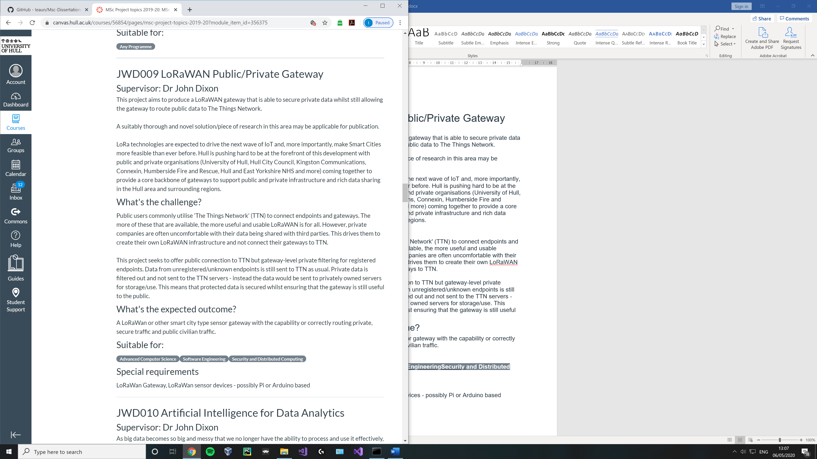

## Appendix 1.2: Ethics form

## 

## Appendix 1.3:

##### Gateways in central London, UK

##### What gateways are they using ?

**Figure above left, LoRaWan at position 7 in adjacent table with altitude of 168** (thethingsnetwork, n.d.)

**Figure above , LoRaWan gateways in a subset of Central London, UK.** (thethingsnetwork, n.d.)

|  |  |  |
| --- | --- | --- |
| **No** | **Brand / Model** | **Altitude (m)** |
| 1 | Laird, Sentrius RG186 (x2) | 30 |
|  | Dragino, LG305 | 30 |
|  | Dragino, LPS8 | 30 |
| 2 | Kerlink, not specified | 26 |
|  | Multitech, not specified | 6 |
| Laird, Sentrius RG186 | 6 |
| 3 | MultiTech, not specified | 54 |
|  | Kerlink, not specified | 61 |
| 4 | Tektelic, KONA Micro | - |
|  | Kerlink, station | 68 |
| 5 | Raspberry Pi based, 831 | 3 |
|  | The Things Indoor Gateway | - |
| Kerlink, not specified | 76 |
| 6 | Kerlink, not specified | 54 |
|  | Kerlink, station | - |
| Kerlink, not specified | 62 |
| 7 | Raspberry Pi based, PiSupply | 15 |
|  | Raspberry Pi based | 168 |
| The Things Indoor Gateway | 35 |
| 8 | Kerlink, not specified | 69 |
|  | Raspberry Pi based, 7243 | 60 |
| 9 | Laird, Sentrius RG186 | 19 |
|  | The Things Indoor Gateway | 20 |
|  | The Things Gateway | 18 |
| 10 | Kerlink, not specified | 20 |
|  | | |
|  | Kerlink | 43 |

##### Gateways in Manchester, UK

##### What gateways are they using ?

|  |  |  |
| --- | --- | --- |
| **No** | **Brand / Model** | **Altitude (m)** |
| 1 | Kerlink, Station | 27 |
| 2 | - | 20 |
| 3 | TTN-001-868-1.0 | - |
|  | Kerlink, Station | - |
| 4 | The Things Gateway | 26 |
|  | Kerlink, Station | - |
|  | Kerlink, Station | - |
| 5 | Kerlink, Station | - |
|  | Laird, Sentrius RG186 | 48 |
|  | The Things Indoor Gateway | 74 |
| 6 | - | 80 |
| 7 | Laird, not specified | - |
|  | Laird, Sentrius RG186 | - |
|  | | |
|  | Kerlink, Station | 46 |

**Figure above , LoRaWan gateways in a subset of Manchester, UK.** (thethingsnetwork, n.d.)

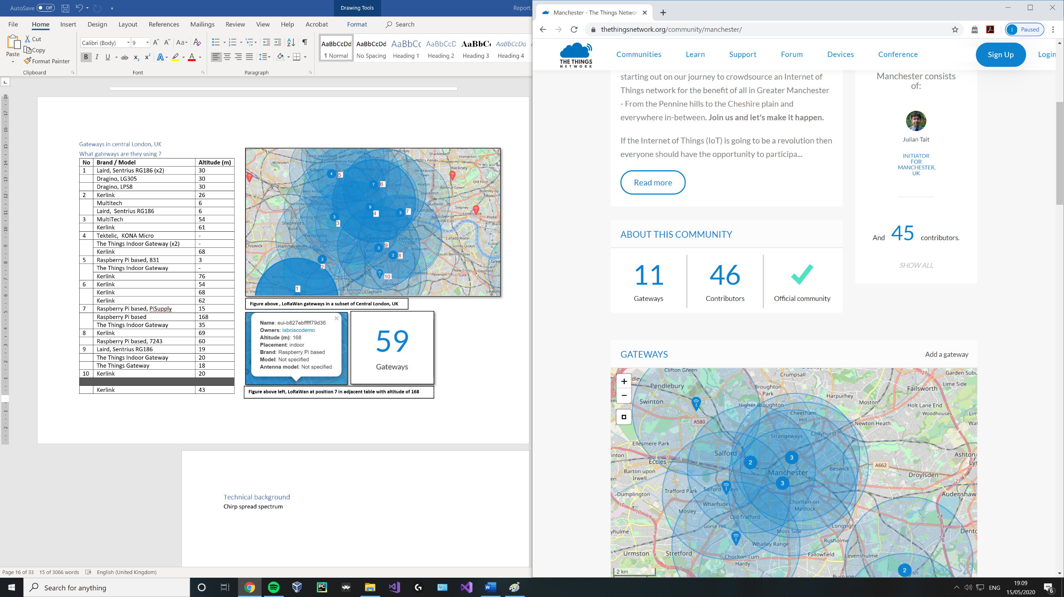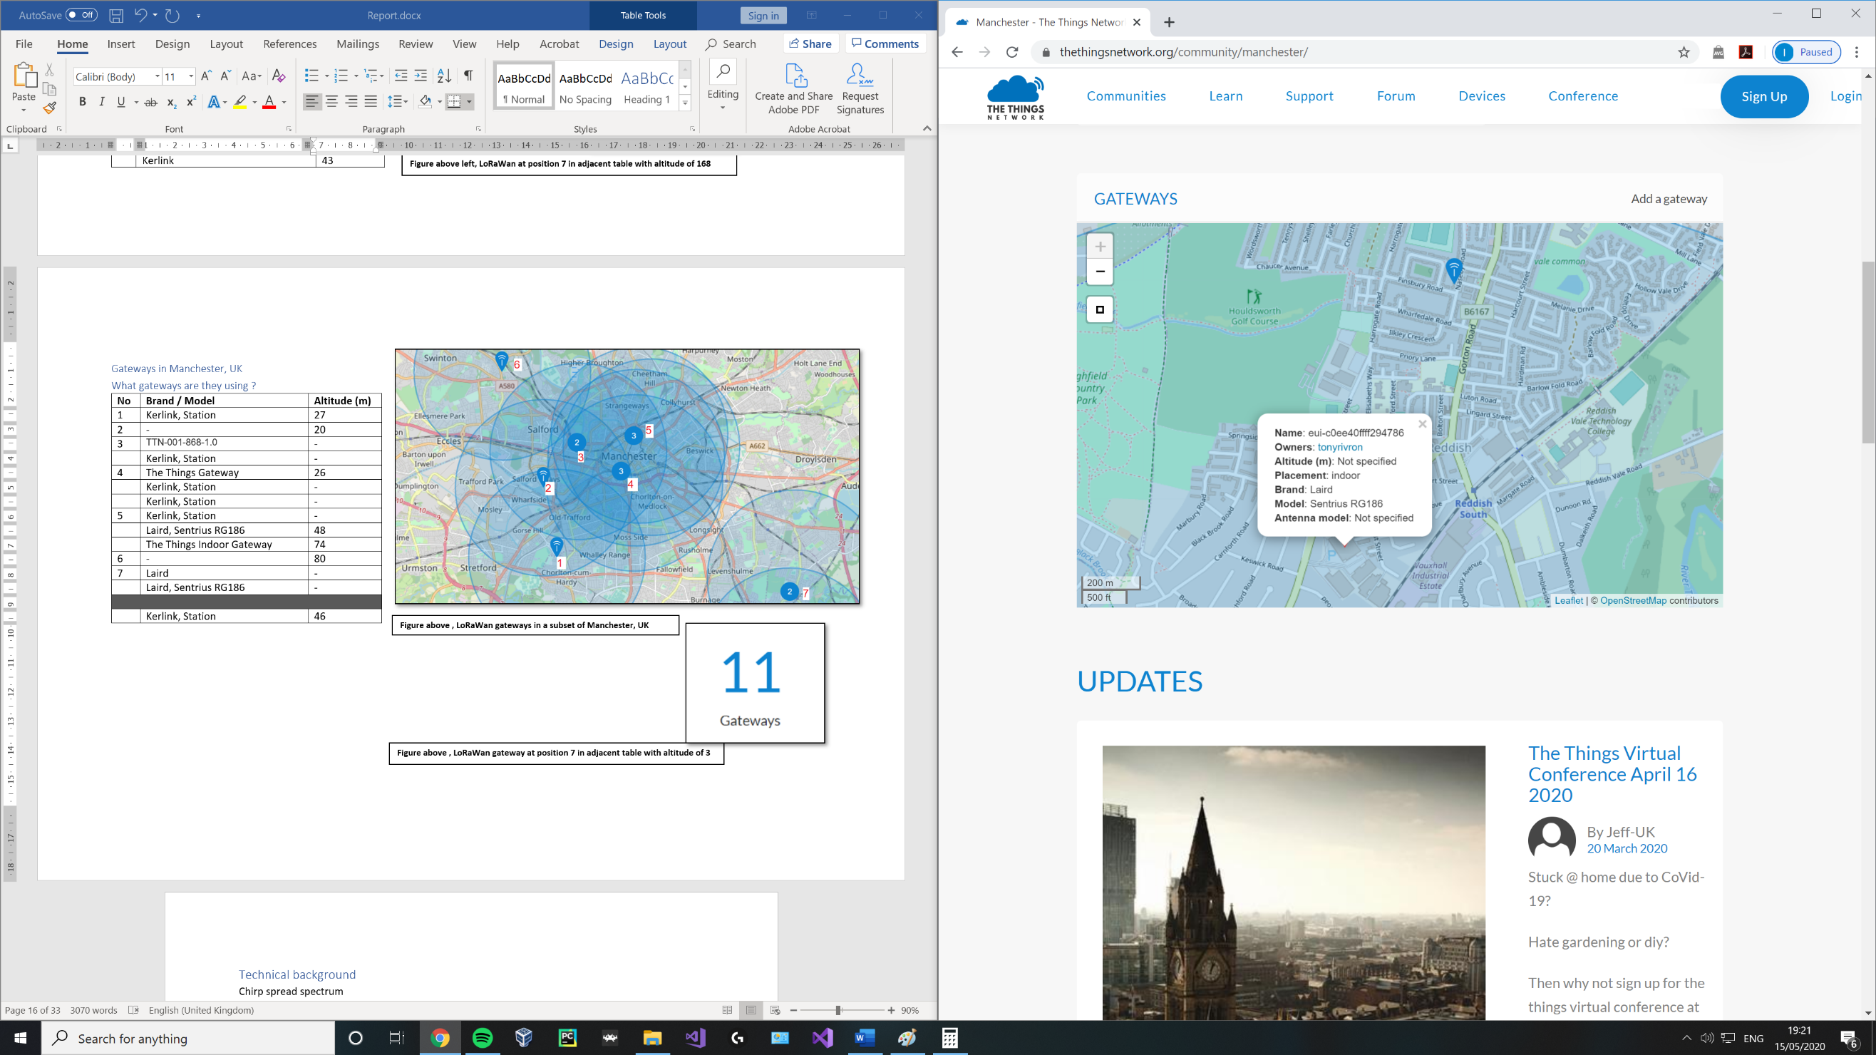

**Figure above , LoRaWan gateway at position 7 in adjacent table using a Laird Sentruis** (thethingsnetwork, n.d.)

##### Gateways in Liverpool, UK

##### What gateways are they using ?

**Figure above , LoRaWan gateways in a subset of Liverpool, UK.** (thethingsnetwork, n.d.)

|  |  |  |
| --- | --- | --- |
| **No** | **Brand / Model** | **Altitude (m)** |
| 1 | Raspberry Pi based | 22 |
|  | - | 107 |
|  | Raspberry Pi based | - |
|  | IOTLTD v. 10 | 42 |
|  | IOTLTD v. 10 | 93 |
|  | IOTLTD v. 10 | 87 |
|  | The Things Indoor Gateway | 20 |
| 2 | IOTLTD | - |
|  | Raspberry Pi based | - |
|  | Raspberry Pi with IMST iC880A | 3 |
|  | IOTLTD v. 10 | 28 |
|  | Gemtek, TTIOG | 30 |
|  | Laird Sentrius RG186 | 60 |
|  | The Things Indoor Gateway | - |
|  | The Things Gateway | 46 |
|  | IOTLTD v. 10 | 176 |
|  | - | 82 |
|  | Raspberry Pi based | 5 |
| 3 | Raspberry Pi based | 70 |
|  | Raspberry Pi based, IMST | - |
|  | Raspberry Pi based | - |
|  | Raspberry Pi based | - |
|  | | |
|  | IOTLTD v. 10 | 58 |

**Figure above , LoRaWan gateway at position 2 in adjacent table using a Laird Sentruis.** (thethingsnetwork, n.d.)

##### Gateways in Birmingham, UK

##### What gateways are they using ?

|  |  |  |
| --- | --- | --- |
| **No** | **Brand / Model** | **Altitude (m)** |
| 1 | MultiTech, Conduit | 20 |
| 2 | The Things Indoor Gateway | - |
| 3 | The Things Indoor Gateway | - |
|  | The Things Indoor Gateway | - |
|  | | |
|  | The Things Indoor Gateway | 20 |

**Figure above , LoRaWan gateways in a subset of Birmingham, UK.** (thethingsnetwork, n.d.)

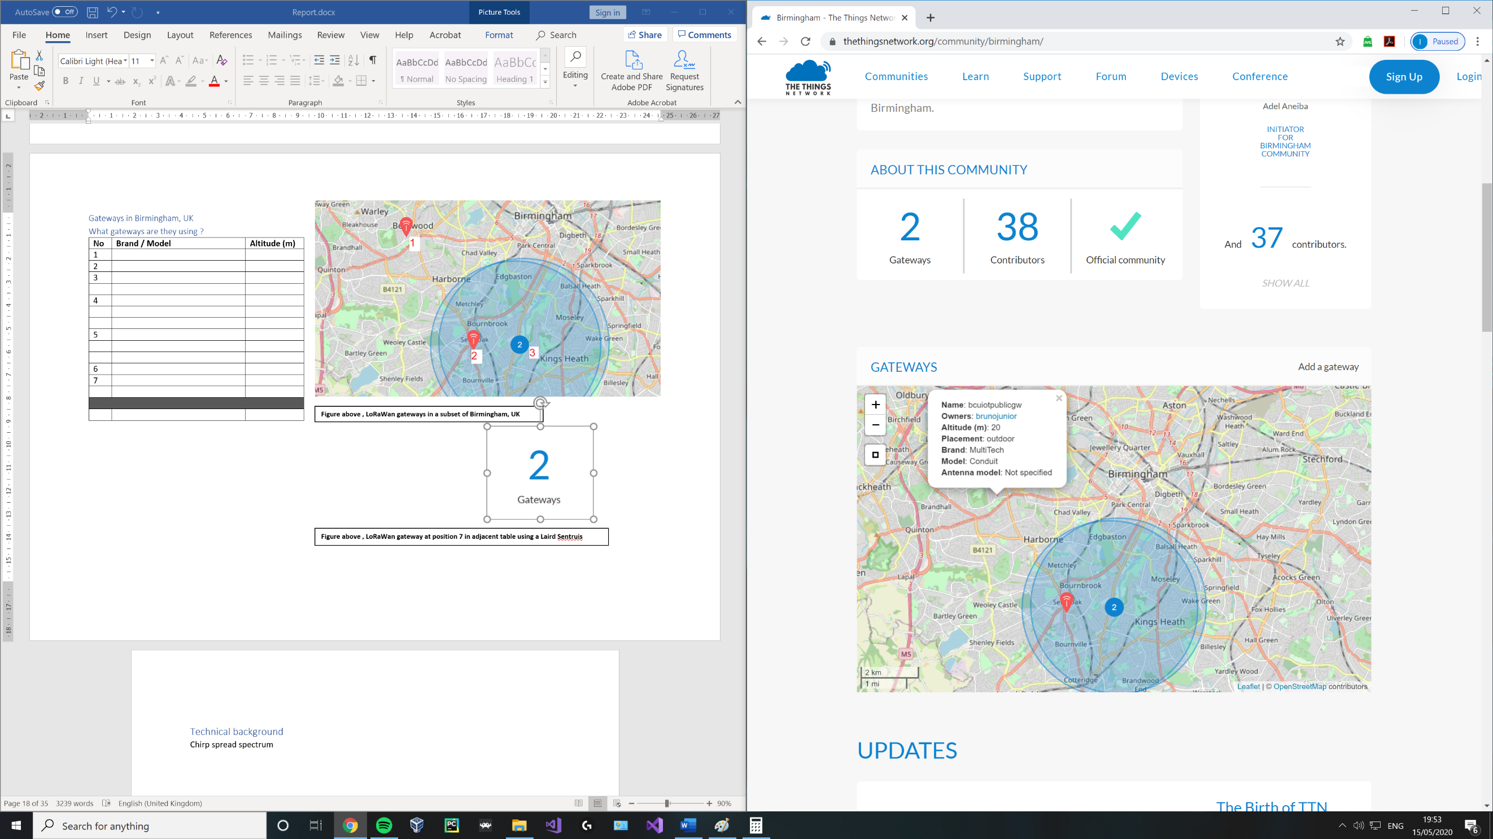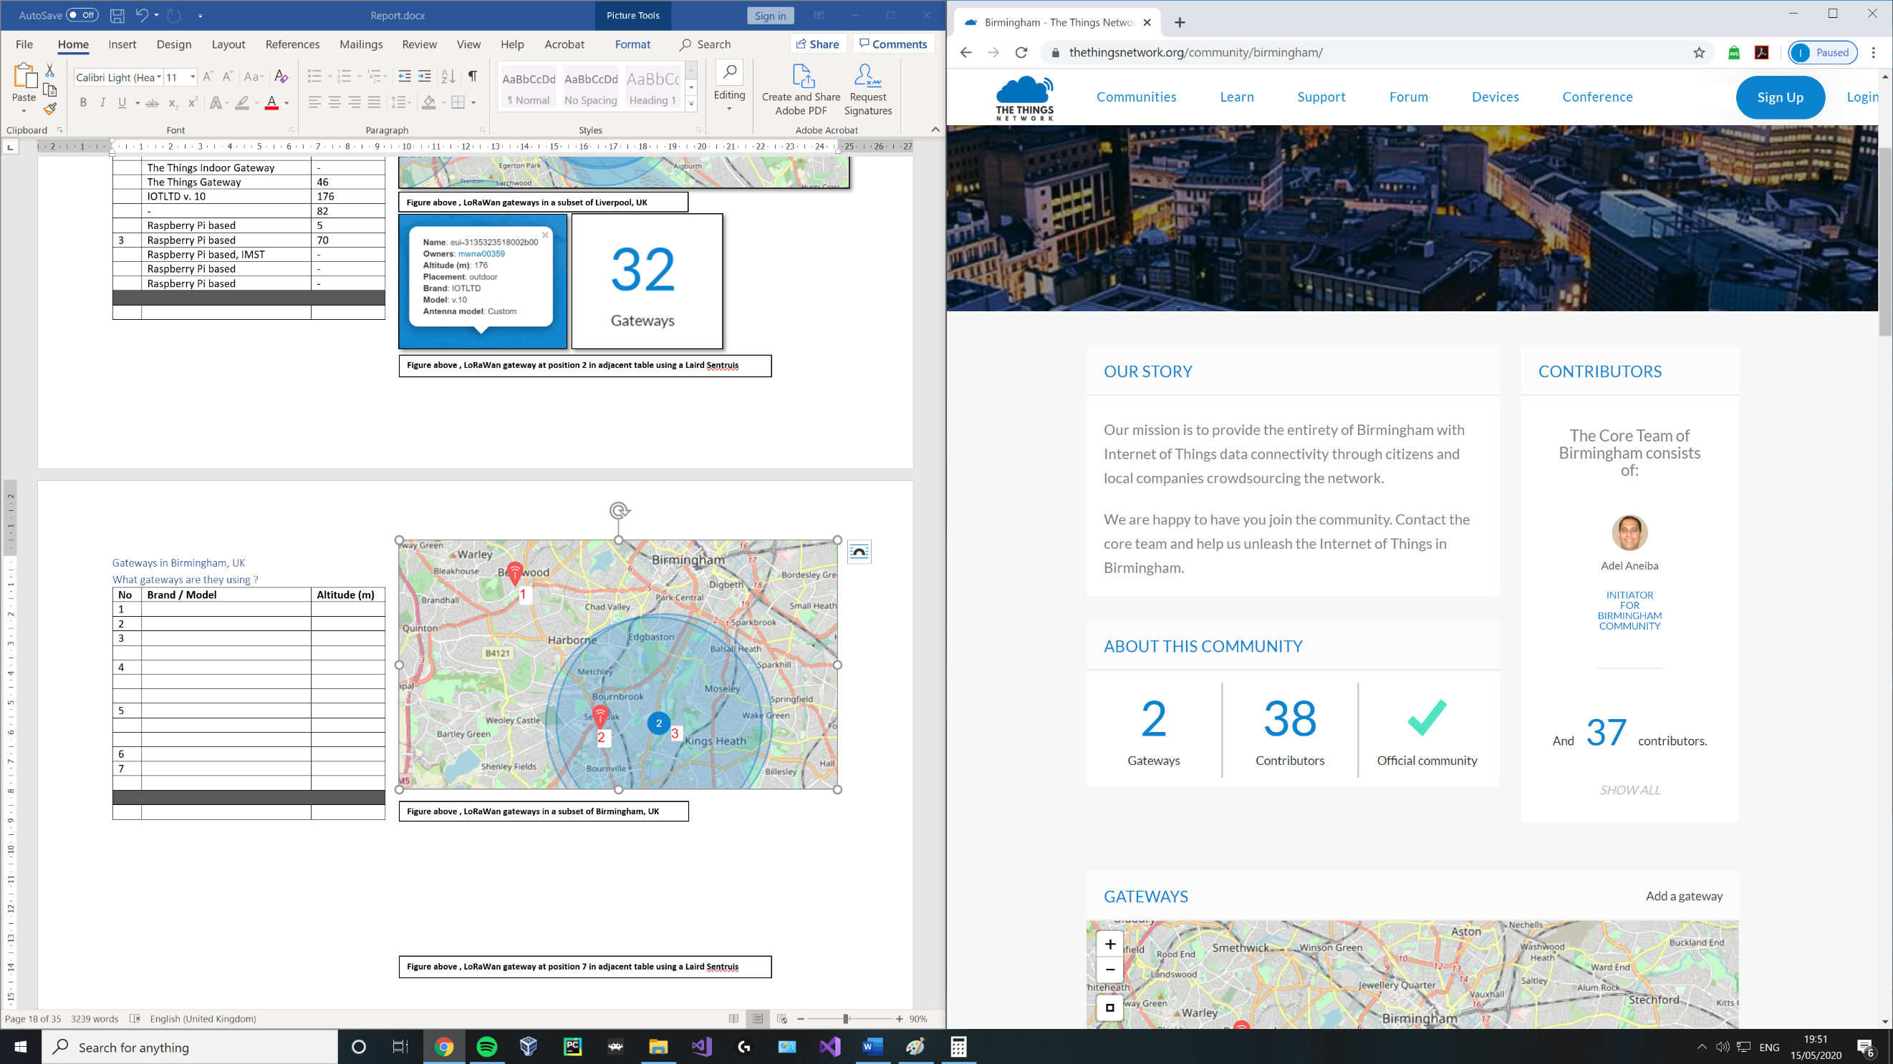

**Figure above , LoRaWan gateway at position 1 in adjacent table using a MultiTech, Conduit** (thethingsnetwork, n.d.)

##### Gateways in Leeds and Bradford, UK

##### What gateways are they using ?

|  |  |  |
| --- | --- | --- |
| **No** | **Brand / Model** | **Altitude (m)** |
| 1 | Raspberry Pi based, RAK831 | - |
| 2 | Kerlink, Station | 173 |
| 3 | Kerlink, Station | 154 |
| 4 | Kerlink, Femtocell | 4 |
|  | MultiTech, Conduit | 50 |
|  | The Things Indoor Gateway | - |
| 5 | Beagle Bone Black with RAK831 | 120 |
|  | Cisco, IXM | - |
|  | MultiTech, Conduit | 50 |
|  | | |
|  | Kerlink, Station /  MultiTech, Conduit | 92 |

**Figure above , LoRaWan gateways in Leeds and Bradford, UK** (thethingsnetwork, n.d.)

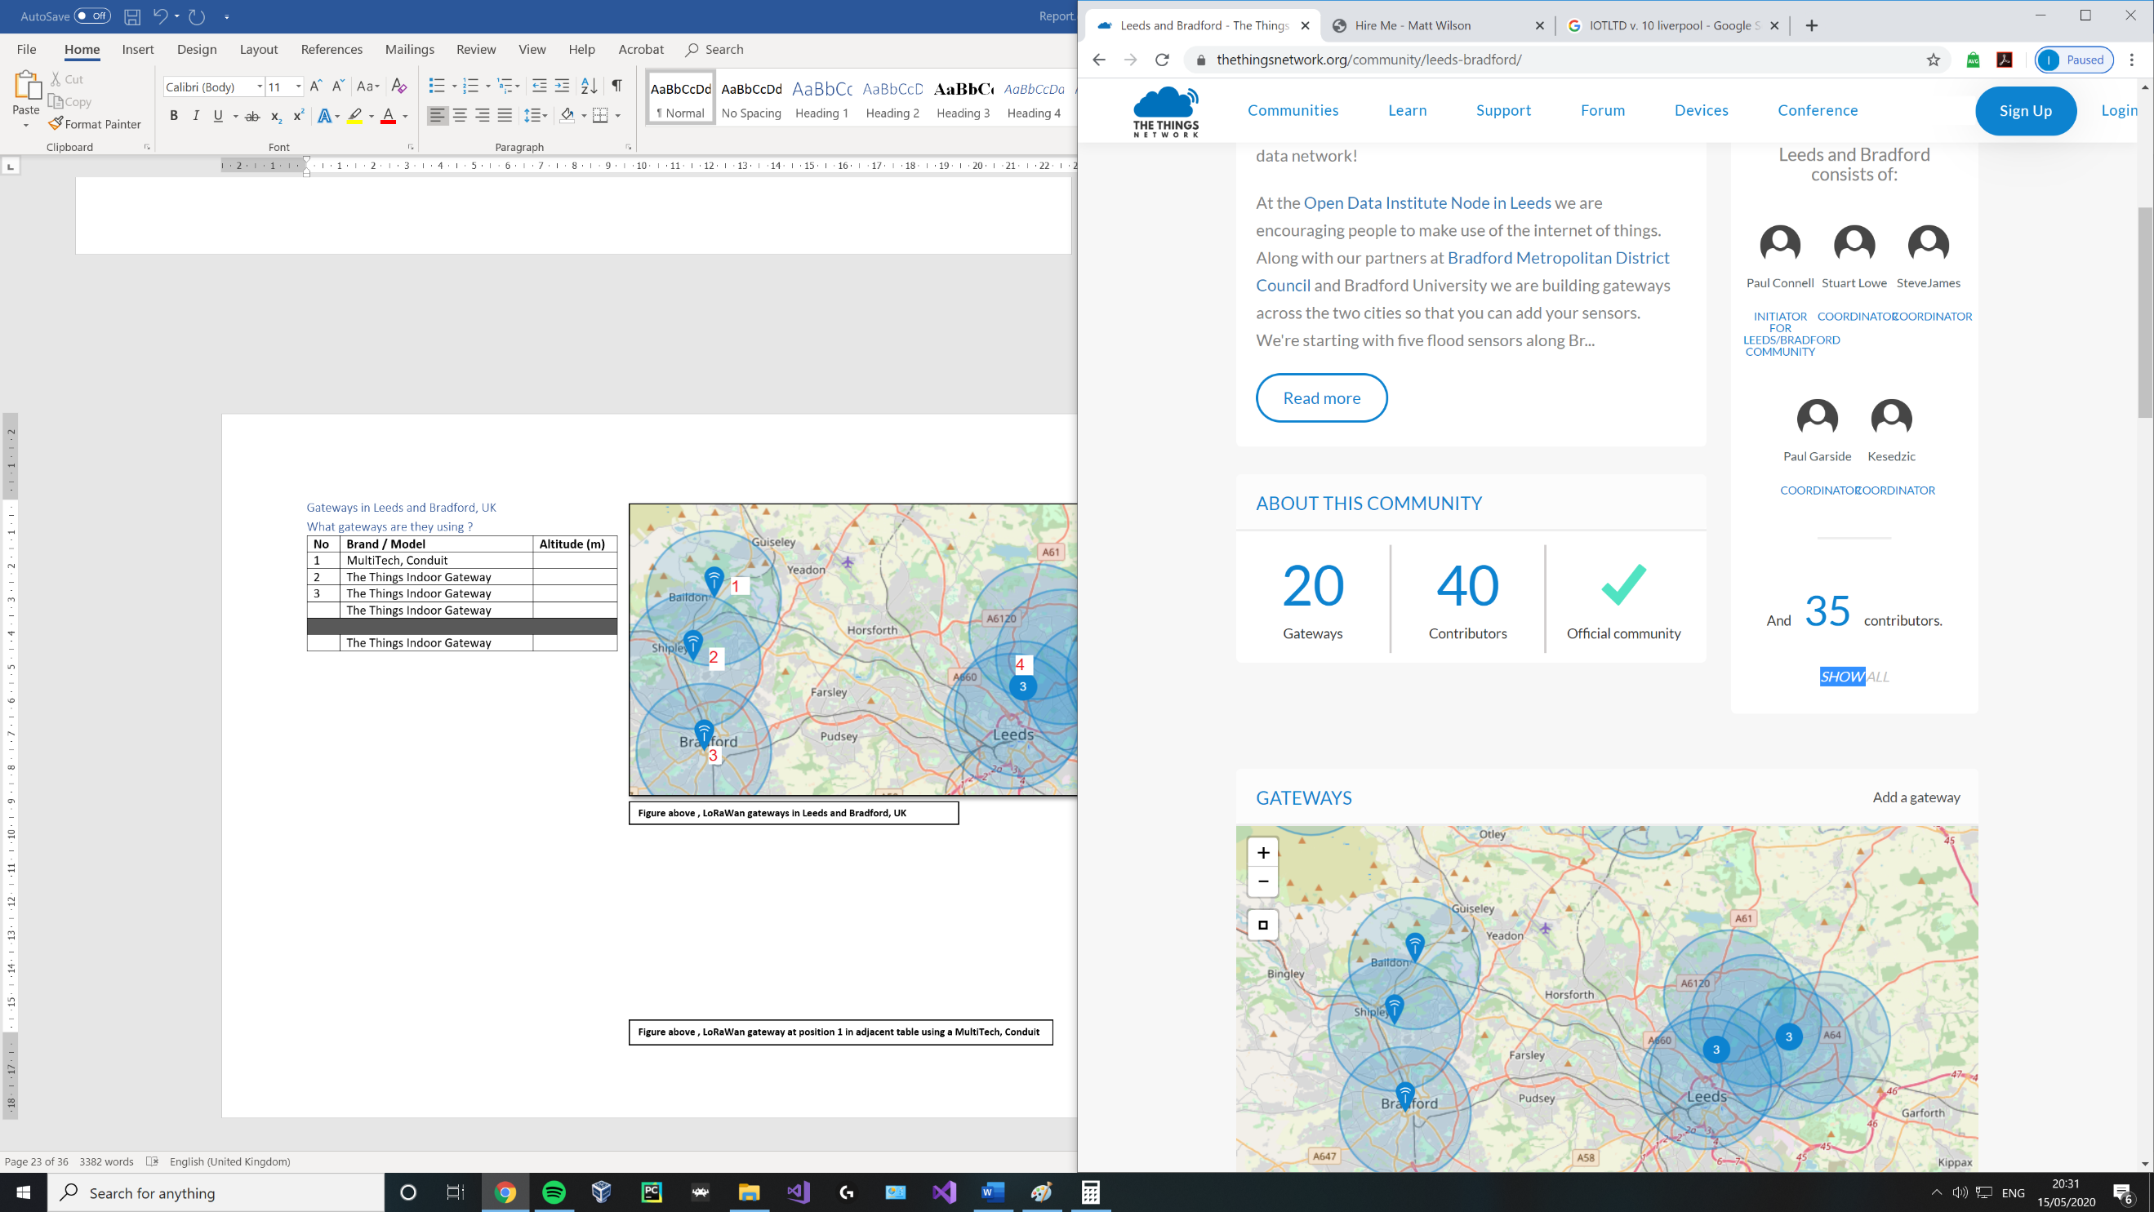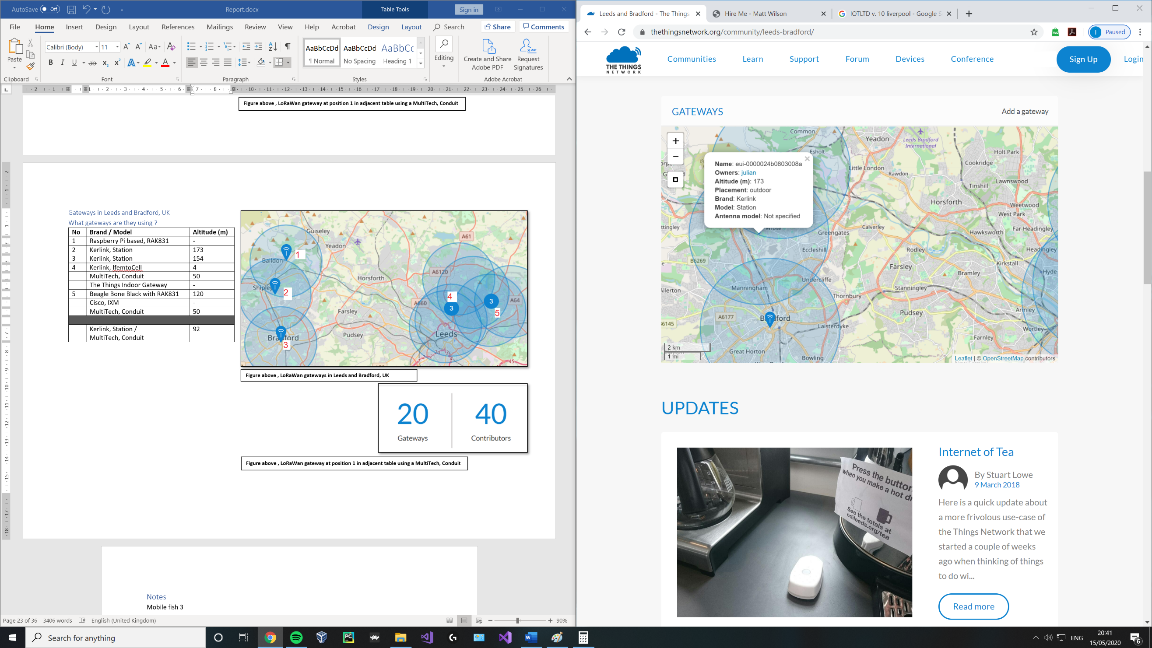

**Figure above , LoRaWan gateway at position 1 in adjacent table using a MultiTech, Conduit** (thethingsnetwork, n.d.)

# References

Antratek, 2020. *www.antratek.com.* [Online]   
Available at: https://www.antratek.com/10-channel-lorawan-gateway-4g  
[Accessed 2020].

britannica, n.d. *britannica.com.* [Online]   
Available at: https://www.britannica.com/technology/modulation-communications  
[Accessed 27 05 2020].

Cola, P., 2018. *linkedin.com.* [Online]   
Available at: https://www.linkedin.com/pulse/ip-over-lorawan-philippe-cola  
[Accessed 05 2020].

dragino, 2019. *dragino.com.* [Online]   
Available at: https://www.dragino.com/products/module/item/102-lora-shield.html  
[Accessed May 2020].

electronicspecifier, 2020. *electronicspecifier.com.* [Online]   
Available at: https://www.electronicspecifier.com/news/analysis/managing-power-in-the-iot-with-cellular-lpwan-technology  
[Accessed 05 2020].

EMMA GOOD, F. J., 2018. *Evaluating LoRaWAN for IoT applications by developing a wireless parking space monitoring sensor,* STOCKHOLM, SWEDEN: KTH ROYAL INSTITUTE OF TECHNOLOGY.

kerlink, n.d. *kerlink.com.* [Online]   
Available at: https://www.kerlink.com/product/wirnet-station/  
[Accessed 14 05 2020].

lora-alliance, 2015. *lora-alliance.org.* [Online]   
Available at: https://lora-alliance.org/sites/default/files/2018-05/2015_-_lorawan_specification_1r0_611_1.pdf#page=34  
[Accessed 26 05 2020].

lora-alliance, n.d. *lora-alliance.org.* [Online]   
Available at: https://lora-alliance.org/about-lorawan  
[Accessed 27 05 2020].

lora-alliance, n.d. *lora-alliance.org/sites/default/files/2019-05/lorawan_security_whitepaper.* [Online]   
Available at: https://lora-alliance.org/sites/default/files/2019-05/lorawan_security_whitepaper.pdf  
[Accessed 16 May 2020].

lora-developers, n.d. *lora-developers.semtech.com/library/tech-papers-and-guides/lorawan-class-a-devices/.* [Online]   
Available at: https://lora-developers.semtech.com/library/tech-papers-and-guides/lorawan-class-a-devices/  
[Accessed 25 05 2020].

mobilefish, 2018. *www.mobilefish.com.* [Online]   
Available at: https://www.mobilefish.com/download/lora/lora_part7.pdf  
[Accessed 14 05 2020].

Mobilefish, 2018. *www.mobilefish.com.* [Online]   
Available at: https://www.mobilefish.com/download/lora/lora_part6.pdf  
[Accessed 13 05 2020].

MobileFish, 2018. *www.mobilefish.com.* [Online]   
Available at: https://www.mobilefish.com/download/lora/lora_part4.pdf  
[Accessed 14 05 2020].

Mobilefish, 2018. *www.mobilefish.com/download/lora/lora_part3.pdf.* [Online]   
Available at: https://www.mobilefish.com/download/lora/lora_part3.pdf  
[Accessed May 2020].

Mobilefish, 2018. *www.mobilefish.com/download/lora/lora_part7.pdf.* [Online]   
Available at: https://www.mobilefish.com/download/lora/lora_part7.pdf  
[Accessed 15 05 2020].

mobilefish, 2018. *www.mobilefish.com/download/lora/lora_part8.pdf.* [Online]   
Available at: https://www.mobilefish.com/download/lora/lora_part8.pdf  
[Accessed 28 May 2020].

N. Sornin (Semtech), M. L. (. T. E. (. T. K. (., 2015. *LoRaWAN Specification.* 1.0 ed. CA: LoRa Alliance .

RAK, n.d. *doc.rakwireless.com.* [Online]   
Available at: https://doc.rakwireless.com/datasheet/rakproducts/rak811-lora-module-datasheet  
[Accessed 15 05 2020].

semtech, n.d. *semtech.com.* [Online]   
Available at: https://www.semtech.com/products/wireless-rf/lora-transceivers/sx1272  
[Accessed 05 2020].

semtech, n.d. *semtech.com.* [Online]   
Available at: https://www.semtech.com/lora/what-is-lora  
[Accessed 05 26 2020].

semtech, n.d. *semtech.com.* [Online]   
Available at: https://www.semtech.com/lora/lora-applications/smart-healthcare  
[Accessed 26 05 2020].

semtech, n.d. *www.semtech.com/products/wireless-rf/lora-gateways/sx1301.* [Online]   
Available at: https://www.semtech.com/products/wireless-rf/lora-gateways/sx1301  
[Accessed 10 May 2020].

Seneviratne, P., 2019. *Beginning Lora Radio networks with arduino.* 1st ed. s.l.:Apress.

Skrypt, 2019. *hackaday.io.* [Online]   
Available at: https://hackaday.io/project/164242-skrypt  
[Accessed May 2020].

Supply, P., n.d. *uk.pi-supply.com.* [Online]   
Available at: https://uk.pi-supply.com/products/rak811-lora-lorawan-tracker-board-wireless-remote-positioning-solution-max-7q-gps-module-mems-sensor  
[Accessed 13 05 2020].

thethingsnetwork, n.d. *https://www.thethingsnetwork.org/community/birmingham/.* [Online]   
Available at: https://www.thethingsnetwork.org/community/birmingham/  
[Accessed 16 May 2020].

thethingsnetwork, n.d. *https://www.thethingsnetwork.org/community/leeds-bradford/.* [Online]   
Available at: https://www.thethingsnetwork.org/community/leeds-bradford/  
[Accessed 16 May 2020].

thethingsnetwork, n.d. *thethingsnetwork.org.* [Online]   
Available at: https://www.thethingsnetwork.org/docs/lorawan/duty-cycle.html#maximum-duty-cycle  
[Accessed 26 05 2020].

thethingsnetwork, n.d. *thethingsnetwork.org maximum-duty-cycle.* [Online]   
Available at: https://www.thethingsnetwork.org/docs/lorawan/duty-cycle.html#maximum-duty-cycle  
[Accessed 26 05 2020].

thethingsnetwork, n.d. *thethingsnetwork.org/community/hull.* [Online]   
Available at: https://www.thethingsnetwork.org/community/hull/  
[Accessed 16 May 2020].

thethingsnetwork, n.d. *www.thethingsnetwork.org.* [Online]   
Available at: https://www.thethingsnetwork.org/docs/lorawan/classes.html  
[Accessed 27 05 2020].

thethingsnetwork, n.d. *www.thethingsnetwork.org/#metrics.* [Online]   
Available at: https://www.thethingsnetwork.org/#metrics  
[Accessed 26 May 2020].

thethingsnetwork, n.d. *www.thethingsnetwork.org/community/liverpool/.* [Online]   
Available at: https://www.thethingsnetwork.org/community/liverpool/  
[Accessed 16 May 2020].

thethingsnetwork, n.d. *www.thethingsnetwork.org/community/london/.* [Online]   
Available at: https://www.thethingsnetwork.org/community/london/  
[Accessed 16 May 2020].

thethingsnetwork, n.d. *www.thethingsnetwork.org/community/manchester/.* [Online]   
Available at: https://www.thethingsnetwork.org/community/manchester/  
[Accessed 16 May 2020].

TTN, 2017. *thethingsnetwork.org.* [Online]   
Available at: https://www.thethingsnetwork.org/article/ground-breaking-world-record-lorawan-packet-received-at-702-km-436-miles-distance  
[Accessed 05 2020].

wienkegiezeman, 2015. *thethingsnetwork.org.* [Online]   
Available at: https://www.thethingsnetwork.org/forum/t/the-things-network-launches/33  
[Accessed 13 05 2020].